Speaking Cue Card Class 😊

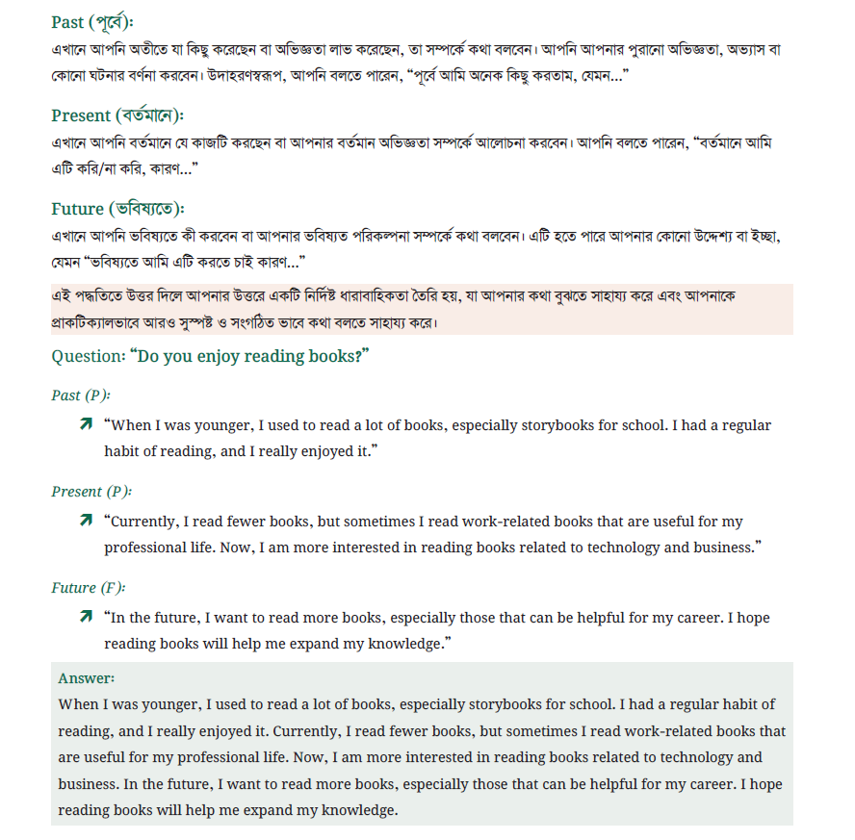

Person related question:
- Uni k?
- Nam or identity
- Apnar sathe relation ( kkhn/kothay/ kivabe porichoy)
- Age, study, ki kore(profession), koi thake, dekha kmn hoy
- Personality traits, habits, manner, skill, achievements etc.
- Unar sathe ekta experience, situation ,advice,
- Why uni interesting
- Effect on you, what you learned
- Present relationship
- Future intention
- How you feel about him

Place related question:
- Where (name of the place), city, urbal or rural, country, area
- Distance, how to go there
- Who you went with
- Layout, sizes, buildings, landscape,
- lighting, color, natural feature, environment, weather, crowd, smell
- facilities, what you can do, what people normally,
- one memorable momet,
- any change over time?
- How you feel
- Negative, recommendation

Things or objects:
- What it is? (name)
- Koi theke ashce
- K diche
- Khn paichen
- Koto din dhore ache
- Value/ cost / symbolic value, dham Kemon?
- Size, shape, color, appearance, weight, condition,
- Uses, use kkmn/ kotobar hop, kivabe kaj kore, special kono feature,
- Why important?
- Repaid/replacement/ upgrade.
- Storage.

Event or experience:
- What kind of event
- Details ( date, location, time)
- Kara chilo? Organizer, participants
- What happened? (starting -> middle ->end)
- What you did? ( short story)
- who was performing something
- Why do people enjoy/ hate this kind of event?
- Outcome

Activity:
(to do something)
- What the activity is
- When/ where koren ?
- Frequency
- Duration
- With whom?
- Why started = motivation ki?
- Prep (equipment, steps, skill, favourite part etc)
- Positive side, negative sides
- One memorable time
- Future target

Describe a Person who helps others.

Bad note:
I am going to talk about my uncle who is forty-five years old. I met him when I was a child. He is very helpful because he helped me choose my university subject. I respect him very much.

Good note:
Rafiq uncle – 45ish-teacher
Known since birth
Mosjid e dekha
Calm + practical
- Uni Sub choice: 3 ta option
Feel: trust, learned teaching

